**SQL Queries**

1) Write a query for the HR department to produce the addresses of all the departments.

Use the LOCATIONS and COUNTRIES tables. Show the location ID, street address,

city, state or province, and country in the output. Run the query



* Select location_id,street_address,city,state_province,country_name
* From locations l
* Join countries c
* On l.country_id = c.country_id;

2) The HR department needs a report of employees in Toronto. Display the last name, job,

department number, and department name for all employees who work in Toronto.



* select last_name,job_id,d.department_id,department_name
* from employees e
* join departments d
* on e.department_id = d.department_id
* join locations l
* on l.location_id = d.location_id
* where l.city = 'toronto';

3) Create a report for HR that displays the last name and salary of every employee who reports to

King.



* select last_name, salary from employees
* where manager_id =
* (select employee_id from employees where last_name = 'king');

4) Create Table MY_EMPLOYEE. Description is shown below:

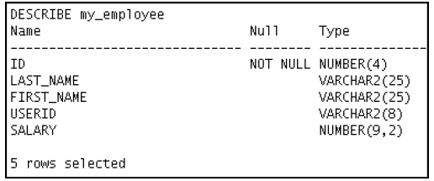

* create table my_employee(id int(4) not null,last_name varchar(25),first_name varchar(25),userid varchar(8),salary int(9));
* desc my_employee;

5) Add the following data to the MY_EMPLOYEE table

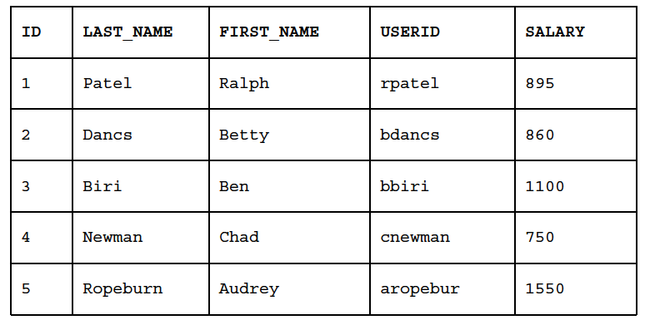

* insert into my_employee values
* (1,'patel','ralph','rpatel',895),
* (2,'dance','betty','bdance',860),
* (3,'biri','ben','bbiri',1100),
* (4,'newman','chad','cnewman',750),
* (5,'ropeburn','audrey','aropebur',1550);

6) Change the last name of employee 3 to Drexler.

* update my_employee set last_name = 'drexler' where id = 3;

7) Change the salary to $1,000 for all employees who have a salary less than $900.

* update my_employee set salary = 1000 where salary < 900;

8) Delete Betty Dancs from the MY_EMPLOYEE table.

* delete from my_employee where first_name = 'betty' and last_name = 'dance';

9) Mark an intermediate point in the processing of the transaction.

* savepoint s1;

10) Delete all the rows from the MY_EMPLOYEE table. Confirm that the table is empty.

* mysql> delete from my_employee;
* Query OK, 4 rows affected (0.00 sec)
* mysql> select * from my_employee;
* Empty set (0.00 sec)

11) Discard the most recent DELETE operation.

* Rollback to s1;

12) Make the data addition permanent.

* Commit;

13) The staff in the HR department wants to hide some of the data in the EMPLOYEES table. Create

a view called EMPLOYEES_VU based on the employee numbers, employee last names, and

department numbers from the EMPLOYEES table. The heading for the employee name should be

EMPLOYEE.

Confirm that the view works. Display the contents of the EMPLOYEES_VU view

* create view EMPLOYEES_VU as select employee_id,last_name employee,department_id from employees;

//for confirmation of view

mysql> select * from employees_vu;

+-------------+-------------+---------------+

| employee_id | employee | department_id |

+-------------+-------------+---------------+

| 100 | King | 90 |

| 101 | Kochhar | 90 |

| 102 | De Haan | 90 |

| 103 | Hunold | 60 |

| 104 | Ernst | 60 |

| 105 | Austin | 60 |

| 106 | Pataballa | 60 |

| 107 | Lorentz | 60 |

| 108 | Greenberg | 100 |

| 109 | Faviet | 100 |

| 110 | Chen | 100 |

| 111 | Sciarra | 100 |

| 112 | Urman | 100 |

| 113 | Popp | 100 |

| 114 | Raphaely | 30 |

| 115 | Khoo | 30 |

| 116 | Baida | 30 |

| 117 | Tobias | 30 |

| 118 | Himuro | 30 |

| 119 | Colmenares | 30 |

| 120 | Weiss | 50 |

| 121 | Fripp | 50 |

| 122 | Kaufling | 50 |

| 123 | Vollman | 50 |

| 124 | Mourgos | 50 |

| 125 | Nayer | 50 |

| 126 | Mikkilineni | 50 |

| 127 | Landry | 50 |

| 128 | Markle | 50 |

| 129 | Bissot | 50 |

| 130 | Atkinson | 50 |

| 131 | Marlow | 50 |

| 132 | Olson | 50 |

| 133 | Mallin | 50 |

| 134 | Rogers | 50 |

| 135 | Gee | 50 |

| 136 | Philtanker | 50 |

| 137 | Ladwig | 50 |

| 138 | Stiles | 50 |

| 139 | Seo | 50 |

| 140 | Patel | 50 |

| 141 | Rajs | 50 |

| 142 | Davies | 50 |

| 143 | Matos | 50 |

| 144 | Vargas | 50 |

| 145 | Russell | 80 |

| 146 | Partners | 80 |

| 147 | Errazuriz | 80 |

| 148 | Cambrault | 80 |

| 149 | Zlotkey | 80 |

| 150 | Tucker | 80 |

| 151 | Bernstein | 80 |

| 152 | Hall | 80 |

| 153 | Olsen | 80 |

| 154 | Cambrault | 80 |

| 155 | Tuvault | 80 |

| 157 | Sully | 80 |

| 158 | McEwen | 80 |

| 159 | Smith | 80 |

| 160 | Doran | 80 |

| 161 | Sewall | 80 |

| 162 | Vishney | 80 |

| 163 | Greene | 80 |

| 164 | Marvins | 80 |

| 165 | Lee | 80 |

| 166 | Ande | 80 |

| 167 | Banda | 80 |

| 168 | Ozer | 80 |

| 169 | Bloom | 80 |

| 170 | Fox | 80 |

| 171 | Smith | 80 |

| 172 | Bates | 80 |

| 173 | Kumar | 80 |

| 174 | Abel | 80 |

| 175 | Hutton | 80 |

| 176 | Taylor | 80 |

| 177 | Livingston | 80 |

| 178 | Grant | NULL |

| 179 | Johnson | 80 |

| 180 | Taylor | 50 |

| 181 | Fleaur | 50 |

| 182 | Sullivan | 50 |

| 183 | Geoni | 50 |

| 184 | Sarchand | 50 |

| 185 | Bull | 50 |

| 186 | Dellinger | 50 |

| 187 | Cabrio | 50 |

| 188 | Chung | 50 |

| 189 | Dilly | 50 |

| 190 | Gates | 50 |

| 191 | Perkins | 50 |

| 192 | Bell | 50 |

| 193 | Everett | 50 |

| 194 | McCain | 50 |

| 195 | Jones | 50 |

| 196 | Walsh | 50 |

| 197 | Feeney | 50 |

| 198 | OConnell | 50 |

| 199 | Grant | 50 |

| 200 | Whalen | 10 |

| 201 | Hartstein | 20 |

| 202 | Fay | 20 |

| 203 | Mavris | 40 |

| 204 | Baer | 70 |

| 205 | Higgins | 110 |

| 206 | Gietz | 110 |

+-------------+-------------+---------------+

106 rows in set (0.00 sec)